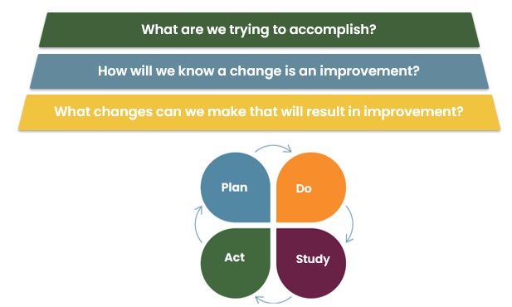
HQBC Improvement Charter

Project Name:

Team Name:

Executive Sponsor:

Team Lead:

Date:

What are we trying to accomplish?

Problem Statement: Adapt for your setting (e.g. local data and/or challenges)

Aim Statement:

Scope and Boundaries: What is included and what isn’t?

How will we know a Change is an improvement?
Measure | Operational Definition | Collection Strategy

Outcome Measures:

Process Measures:

Balancing Measures:

What Changes Can we Make that will result in improvement?

Initial Change Ideas to Test:

Initial PDSA Cycles: What will you test? What are you hoping to learn?

How will we manage the improvement project?

Team Members:
Name | Role/Responsibility

Key Dates: Deadlines, deliverables, vacations, etc.

How will we incorporate the voice of patient partners?

How will we maintain and promote safety (physical, psychological, and cultural) throughout the project?
See BC Health Quality Matrix and Culturally Safe Engagement Companion Guide for more information about safety.

How will we consider environmental sustainability throughout the project?

